Pizza Sales SQL Queries

- KPI’s Requirement in Business

- Total Revenue:
The sum of the total price of all pizza order.
Select SUM(Total_price) As Total_Revenue from pizza_sales;
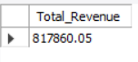
- Average Order Value:
The average amount spends per order, calculated by dividing the total revenue by the total number of orders.
Select SUM(Total_Price)/Count (Distinct(order_id)) As Avg_Order_Value from pizza_sales;
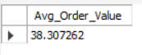
- Total Pizza Sold:
The sum of the quantity of all pizza sold
Select Sum(quantity) As Total_Quantity from pizza_sales;
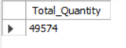
- Total Orders:
The total number of orders placed.
Select Count (Distinct(order_id)) As Total Orders from pizza_sales;
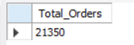

- Average Pizzas per order:
The average numbers of pizzas sold per order, calculated by dividing the total number of pizzas sold by the total numbers of orders.

SELECT
CAST (
CAST(SUM(Quantity) AS DECIMAL (10,2)) / CAST (COUNT (DISTINCT order_id) AS DECIMAL (10,2)) AS DECIMAL (10,2)
)
AS Avg_pizzas_sold_per_order
FROM
pizza_sales;

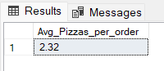
Note: Cast Functions represent to change the digits in specific data type with certain number of decimal digits.
CAST (expression AS Data_Type (10,2))

- KPI’s Requirement in Business

- Daily Trend for Total Order:

Daily Trend of total order over a specific time period. This chart will help us identify any patterns or fluctuations in order volumes a daily basis.

SELECT
DAYNAME (order_date) AS day_name,
dayofweek(order_date) as day_of_week,
COUNT (DISTINCT (order_id)) AS total orders
FROM pizza_sales
GROUP BY day_name, day_of_week
ORDER BY DAYOFWEEK (order_date) asc;

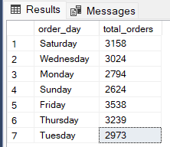

Note: DAYNAME Function returns calendar day name from column order_date, dayofweek function return which day in numeric called dayofweek.

- Monthly Trend for Order:
Monthly trend for total order. This chart will help us identify any patterns or fluctuations in monthly order trend.
Select Monthname(order_date) as month_name,
COUNT (DISTINCT (order_id)) AS total_orders
from pizza_sales
group by month_name, month(order_date)
order by month(order_date);

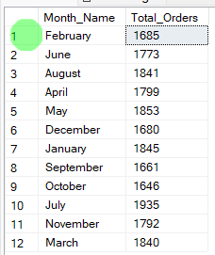

- Percentage of Sales by pizza category:
This trend will show the revenue percentage of total sales by pizza category.
Select pizza_category, Sum(total_price) as category revenue,
Round (Sum(total_price)/ (select sum(total_price) as revenue from pizza_sales) *100,2) as revenue_percentage
from pizza_sales
group by pizza_category
order by revenue_percentage desc;

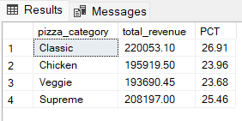

- Percentage of Sales by pizza size:

Select pizza_size, Sum(total_price) as category_revenue,
Round (Sum(total_price)/ (select sum(total_price) as revenue from pizza_sales) *100,2) as revenue_percentage
from pizza_sales
group by pizza_size
order by revenue_percentage desc;

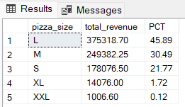

- Total pizza sold by category:
Select pizza_category, Sum (Quantity) As Total_Pizza_order
from pizza_sales
group by pizza_category;

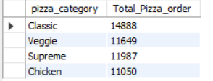

- Top 5 pizza by revenue:

select Pizza_name, Sum(total_price) as revenue
from pizza_sales
group by pizza_name
order by revenue desc
Limit 5;

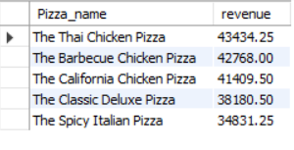
- Bottom 5 pizza by revenue:
select Pizza_name, Sum(total_price) as revenue
from pizza_sales
group by pizza_name
order by revenue asc
Limit 5;

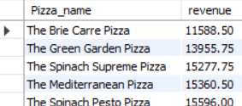

- Top 5 pizza by Quantity:
select Pizza_name, Sum (Quantity) as Total_Quantity
from pizza_sales
group by pizza_name
order by Total_Quantity desc
Limit 5;

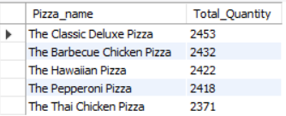
- Bottom 5 pizza by Quantity:

select Pizza_name, Sum (Quantity) as Total_Quantity
from pizza_sales
group by pizza_name
order by Total_Quantity asc
Limit 5;

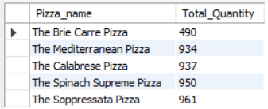

- Top 5 pizza by Order:

select Pizza_name, count (distinct (order_id)) as Total_Order
from pizza_sales
group by pizza_name
order by Total_Order desc
Limit 5;

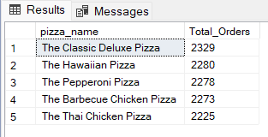

- Bottom 5 pizza by Order:
select Pizza_name, count (distinct (order_id)) as Total_Order
from pizza_sales
group by pizza_name
order by Total_Order asc
Limit 5;

